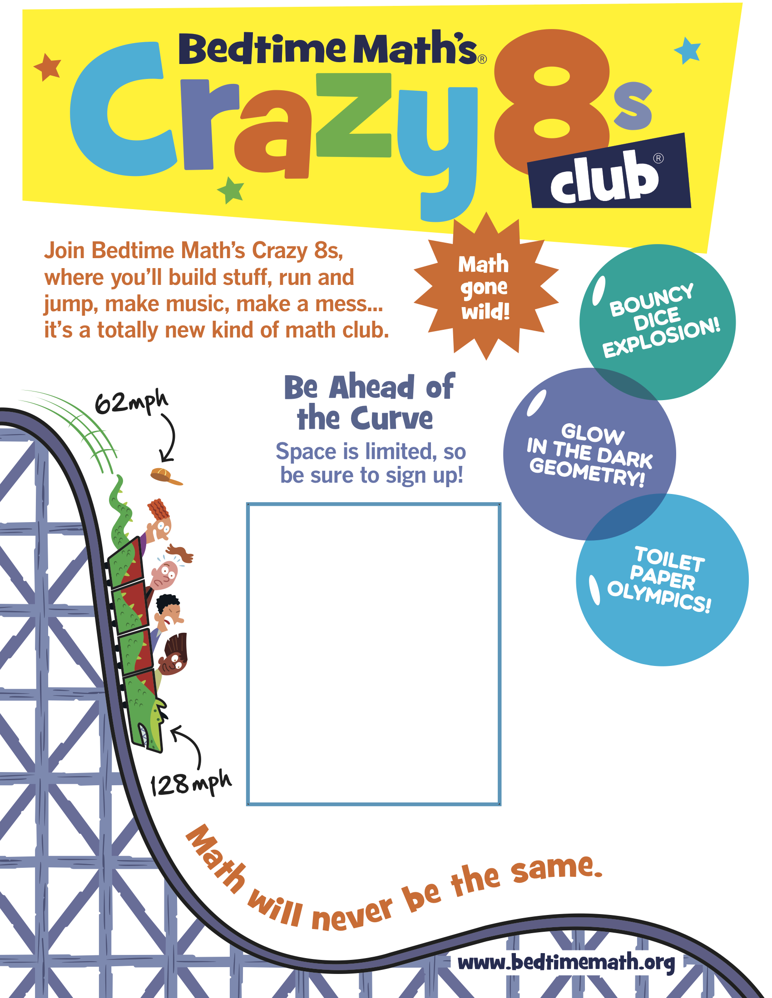
Grades 3-5
Ross Library
February 2 – March 23
3:30 - 4:30
For more info contact:
Meghan.Pazmino@dc.gov

